MACH4METAL

Metalworking machinery
Transito 21,
6909 DA BABBERICH, Netherlands
Tel. + 31 (0)316 – 247123
Fax. + 31 (0)316 - 247956
info@mach4metal.com
www.mach4metal.com

Account No: 66.52.13.883
IBAN : NL33 INGB 0665 2138 83
BIC : INGBNL2A

Dörries Scharmann CNC Vertical Grinding machine
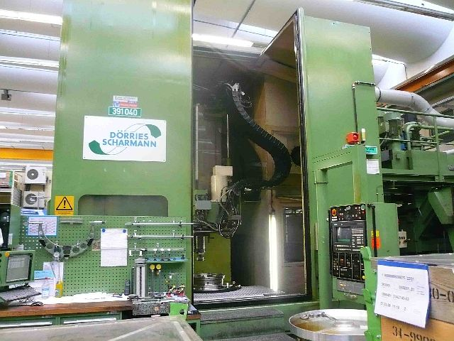

- Make : Dörries – Scharmann
- Typ : VSSC 1500 / 100 S
- Mach.No: M 291 / 51 156
- Age : 1993

- Max. Ø : 1.500
- Table size : 1.000
- Grinding Ø : 1.500

- C = Table 0,001 ° Positioning
- Table speeds 0,01 – 10 m/min
- Y = 950
- Z = 700
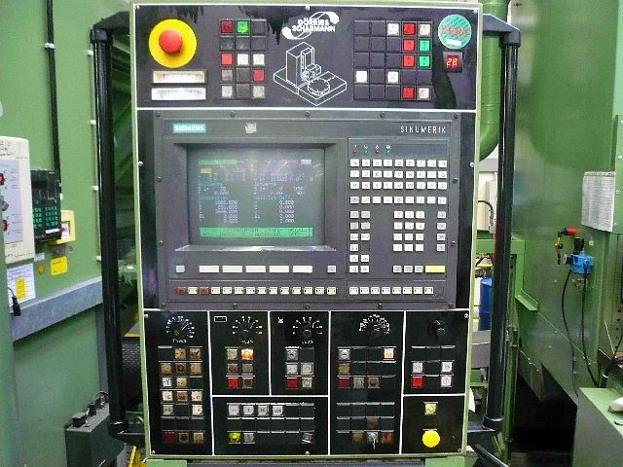
- Spindle Ø: 230

- Grinding spindle power 45 kW
- Speeds 1500 – 8000 Rpm
- Angle Support L + R 135°
- Feeds 0,0001 – 70 m/min
- Rapid till 10 m/min

- Y = Table movement ±: 750
- X = Column movement ±: 950

- Total power 160 kW
- Dimensions: 9,0 x 7,5 x 4,8 Mtr.

- 5 axis CNC Controll
- Siemens 880 G

Please Note: The above information has been obtained to the best of our ability and belief from, and from the manufacturers where possible. It is given in good faith, but its accuracy can not be guaranteed. Accordingly, it will not form a representation or constitute contractual terms. We advise you to check any vital details!

